|  |  |  |  |  |
| --- | --- | --- | --- | --- |
| BOARDD | | | | |
|  |  | | |  |
| Going Viral | | | | |
|  | | Business Plan |  | |

TABLE OF CONTENTS

1. Executive Summary 3

2. Company Overview 4

3. Business Description 6

4. Technological Description 8

5. Market Analysis 16

6. Operating Plan 19

7. Marketing and Sales Plan 21

8. Financial Plan 21

# Executive Summary

Our business is based around the problem of diagnosing infectious respiratory diseases and the publishing of the data of these diagnoses. Our BOARDDs (**B**iometrically **O**bservant **A**utomatic **R**espiratory **D**isease **D**etection) diagnose people with an infectious respiratory disease along with noting the number of people in the room. This data will be sent to our BOARDD server and will be sent to our website. There, it will show the current spread and infective rates, as well as the forecasting of the spread. We plan on implementing this technology in cities, governments, businesses, hospitals, airlines, and many more public facilities. This data can benefit the public greatly in bettering our understanding of the spread of infectious respiratory diseases that could lead to an epidemic or a pandemic. The current awareness and pandemic will open this brand-new market to our business and will allow us to spread throughout the economy.

* **Opportunity:** Diseases spread quickly and can eventually lead to epidemics if they get large enough. They can also often be difficult to diagnose with high accuracy.
* **Mission:** Reporting the spread of diseases and better diagnosing the diseases in question. We are solving for the true amount of people infected with an infectious respiratory disease, allowing for better planning and disease prevention in communities.
* **Solution:** Our service uses a machine-learning algorithm to identify a disease through a cough, and then report it to a website that shows the spread of the disease.
* **Market Focus:** Our product’s main market is businesses, hospitals, governments, and other public facilities.
* **Competitive Advantage:** Currently, there is no other serviceable to track respiratory diseases with anywhere near this amount of speed and accuracy, and we plan on maintaining our BOARDDs through over-the-air updates to compete with other products.
* Ownership: The owners of the company are as follows: Jesse Anthony, Cecilia Beckerbauer, Owen Hamill, Andrew Heftie, Matthew Heftie, William Thompson.
* **Expected Returns:** The main goal is to provide infrastructure and service that allows communities to track infectious respiratory diseases and better protect their people and economies. The returns from this would be small as we begin to start in just a small city and make more money as our coverage and abilities increase.

# Company Overview

Our BOARDDs reveal how many people are infected with an infectious respiratory disease rather than how many are diagnosed. The problem with diagnoses by a COVID-19 test is the tests can be wrong. They can tell a person that they are positive or negative when it can be the opposite. This has created many problems in the community with data reporting. Additionally, not everyone positive gets a diagnosis. Rather some may just write the infectious respiratory disease off as a cold. With our BOARDDs, there is over 90% accuracy and the people don’t even have to get an official diagnosis. Instead, the BOARDD just needs a cough to diagnose the person and report it to the server which passes the data to the website and the owner of the device. Our team was tasked with the problem of responding to emerging infectious diseases. To do this we decided to focus on accurately diagnosing people and gathering better data about the spread of respiratory disease. Our final goal for the project is for our BOARDDs to be used in communities to gather and better report data as an infrastructure for the reports and tracking of an infectious respiratory disease.

* **Company Summary:** Our BOARDD is a flexible system that provides a real-time diagnosis of various respiratory diseases with high accuracy and uses that data to report real-time disease tracking and forecasting. Right now, our device can diagnose COVID-19 coughs with over 90 percent accuracy and send the data to our server. The same model can also be applied to other respiratory diseases. There the server will tag the data and output it to our website. The website currently shows the data in real-time and we are working on our forecasting feature as of right now which will continue to improve as we learn more about disease spread.
* **Mission Statement:** Our goal as a company is to provide real-time disease tracking for consumers with far greater accuracy, clarity, and speed compared to the current and future competition.
* Company History: With the COVID-19 pandemic currently being afoot from March to the present, lots of problems have occurred. In March of 2020, the United States shut down following many other countries. COVID-19 testing soon became a part of daily life, however, there were lots of problems. Thanks to the globalization of the world, the virus spread rapidly, and soon it was rare to not have a COVID-19 case near you. Precautions soon followed along with things like mask mandates, quarantines, etc. Over time as the precautions have slowly started to be lifted, COVID-19 tests grew even more popular. Our company soon noticed that there were lots of problems with COVID-19 tests. We also noticed that the tests could not keep up with the spread of the virus. With further research, we found that most diseases that lead to a pandemic had the same issues. We started to focus on the spread of diseases (Both bacterial and viral) and the identification of an infected individual. Through research, we found that MIT created a machine learning algorithm that could identify COVID-19 from a cough. This machine-learning algorithm could additionally be applied to other diseases that had symptoms that include a cough. We have adapted this machine learning algorithm into our BOARDDs and have connected the results to a forecasting website that depicts the spread.
* **Markets and Services:** Our main market would be aimed at the public benefit. We aim to have these devices in hospitals, grocery stores, government, and other public facilities and businesses. Our service would be to identify the coughs around the device which will then be diagnosed with an over 90 percent accuracy.
* **Operational Structure:** Our operational structure is based on maintaining our server/websites. Our manufacturing of devices will be done in our homes to start. All current members of our team are part of our essential employees in that they keep our machines running or expand our company.
* Financial Goals: Our main goal is to get a government to invest in these. It can show as a testament to our effectiveness of the BOARDDs. From there other communities can use our BOARDDs as a form of infrastructure and will help them in disease identification, spread, and forecasting.

# Business Description

Our company is trying to provide more accurate diagnoses and data for the spread of infectious respiratory diseases. Currently, there is a problem with misdiagnoses of people and people that are infected but not going to get diagnosed. However, BOARDD solves this all. Our final destinations include hospitals, government buildings, businesses, and other public locations. In these locations, BOARDD can be constantly active and diagnosing coughs as it receives their sound. It will then record its diagnoses and data it collects so that the owners of the devices can access it along with the server. The server then would transfer the files into geoJSON files and output them onto our website on a forecasting layer and a current real-time spread layer. Our business is planning on using this data to spread awareness and give better data to the businesses, governments, hospitals, airlines, etc. This data can eliminate some liabilities, provide data to make better decisions, policies, show the overall spread, show the effectiveness of a vaccine, and so much more.

* **Opportunity:** Currently this is a brand-new market. Thanks to the COVID-19 pandemic, awareness for disease diagnoses and data formed this new market. Our main customers are aimed at hospitals, airlines, government, and other infrastructure. The BOARDD will perfectly fit the need for better diagnoses and data release. This market will truly benefit from our BOARDDs as will the general public.
* **Product Overview:** Our product consists of a BOARDD that will count the number of people in a room while also diagnosing coughs that it recognizes with an over 90 percent accuracy in the diagnosis. The BOARDD will then send the data to the server which will then transfer the data into geoJSON files. These files will be used on the website to report real-time data of where the disease is. Additionally, the website will also use the files to forecast the spread of the disease.
* **Key Participants:** Some critical suppliers, distributors, and referral partners include governments, hospitals, businesses, airlines, public transportation, etc. The BOARDDs will help cities optimize closings and provide them with a better data set. The cities can then use this to make more informed decisions with their economy using the data that they can access through our BOARDDs. A country can use our BOARDDs and data collected to better predict disease spreading and how it truly is spreading. This can show them how close they are to being immune and have a more accurate report on the spread. Businesses can use our BOARDDs and data collected for managing closings while creating and maintaining policies. It also provides an opportunity for businesses to not be as liable for when employees try to sue them based on getting exposed to the disease and then having long-term results. The full situation about the liability of businesses in this sense can be found in the Republican bill for the second stimulus check of 2020-2021. Governments and hospitals can also save lots of money and receive data to better their decisions and reports.
* Pricing: We do have an opportunity to charge more than what it takes to make it, however, the data that we collect is more valuable at first. We plan on selling the BOARDDs for the amount that it takes to make it as we are trying to keep the price low. With a low price, a greater amount of communities will become willing to invest. As that happens we can scale up and refine our technology to increase profits.

# Technological Description

The goal of our BOARDDs is to provide a concise, clear, and accurate depiction of the spread of diseases in real-time. Our prototype is currently trained to run a COVID-19 detection algorithm in a small and cheap package. It was designed to detect coughs in a crowded environment, check if those coughs showed that someone had COVID-19, count the number of people in the room, and send that information to our server to calculate the distribution and concentration of positive cases. The website on our server will provide a “forecast” of where the disease will spread to next with as high accuracy as possible from the data received from both the BOARDD and other hospital and government data. Additionally, our whole system can be applied to any other infectious respiratory disease.

* **Prototype:**

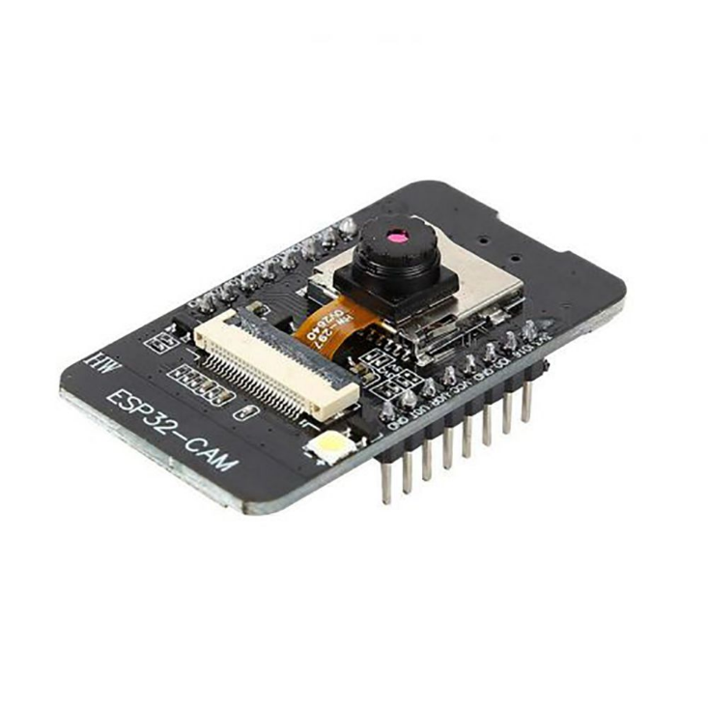

* **First Design of Prototype:** The first design was an ESP-32 with a camera and attached microphone that could run cough detection with TensorFlow lite and identify the number of people in a room with the camera. The first goal of getting cough and COVID-19 detection running on the ESP-32 was accomplished by adapting a lightweight speech detection example included with TensorFlow. Cough data was easily found on GitHub and almost all of the datasets were designed for COVID-19 testing. This made training a model simple. The model was trained using a modified version of the example training code on Google Collab. The original version of the model only reached 80-85% accuracy and after using a larger dataset and removing silence from the dataset the accuracy moved to above 90%. We also switched to setting Jupyter locally to run training due to the difficulty of moving data to Google Collab, allowing us to modify the model parameters and dataset faster.
* **Results & Changes of the Prototype:** Although the ESP-32 successfully ran the cough detection model, attempts to convert existing object detection and crowd counting models proved that the ESP-32 was not powerful enough for this application. Most models that used images wanted hardware support for computer vision in the form of CUDA or OpenCV, which the ESP-32 lacked. The only clear solution at the time was to run the person counting on a much more powerful Nvidia Jetson Nano. Even though the setup worked to identify the number of people in the room, and could detect coughs on the ESP-32, the high cost of the Jetson Nano made the prototype unviable for further development. The Jetson Nano ran YOLOv4 object detection, despite our attempts to find a dedicated crowd counting model. The Jetson Nano used an ARM64 CPU which was unsupported by most dependencies. Because of the high power of the Jetson, multiple ESP-32 video streams could be processed simultaneously allowing for a lower cost per individual point of monitoring. This setup would work as intended but was limited to large-scale deployments with a high entry cost. We began looking for a lower-cost chip similar to the one found in the Intel Neural Compute Stick that would allow for all processing to be run on one board. After looking through dedicated object detection boards, we found the Sipeed M1 and M1W. The M1W contains a two-core RISC-V CPU with a dedicated AI coprocessor allowing it to run YOLOv2 object detection and an integrated ESP8266 for Wi-Fi. Adding a small PCB with microphone and camera creates an all-in-one COVID-19 detection system (That can be applied to any other infectious respiratory disease) for a price under $20.
* Graph of Overlaid Accuracy of Cough Detection & COVID-**19 Testing Models During Training:**

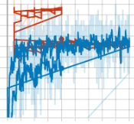

* Final Iteration of Cough Detection Model:

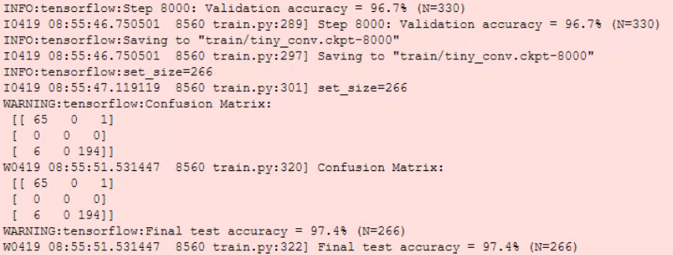

* **Final Iteration of COVID-19 Detection Model:**

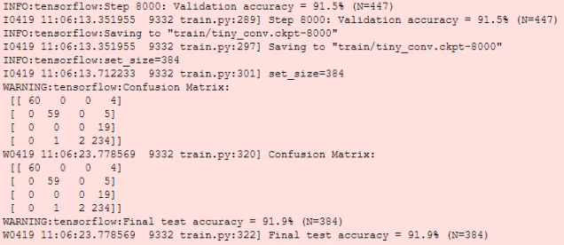

* Current Position of Work on Prototype: Because the M1W was identified late in development, we have not been able to port the cough detection yet. Most of the time spent so far was working on finding the most lightweight models, it should be simple enough to convert the example code to run on the M1W. After removing silence in the COVID-19 dataset, the model can distinguish with about 90% accuracy and identify coughs from background noise with about 97% accuracy. The camera only needs to detect people near the device so the person detection does not need to accurate.
* The custom PCB was created based on the schematic of the Sipeed Maixduino, a board similar to the final goal of the prototype. The board was designed to be as lightweight and cheap as possible, and only contains the processor, camera, and microphone. Due to the long wait times for shipping the SMD parts and PCB from China, the board would not be ready by the final presentation. Despite this, the board is fully functional and we plan on finishing assembly after the competition is over for the experience.
* The PCB is shown here with an added connection for an ESP32. We, unfortunately, discovered that the M1 cannot run TensorFlow and we would need to connect an ESP32 through UART. Although we have successfully gotten the two devices to connect we am not planning on finishing the PCB until we have verified everything works.

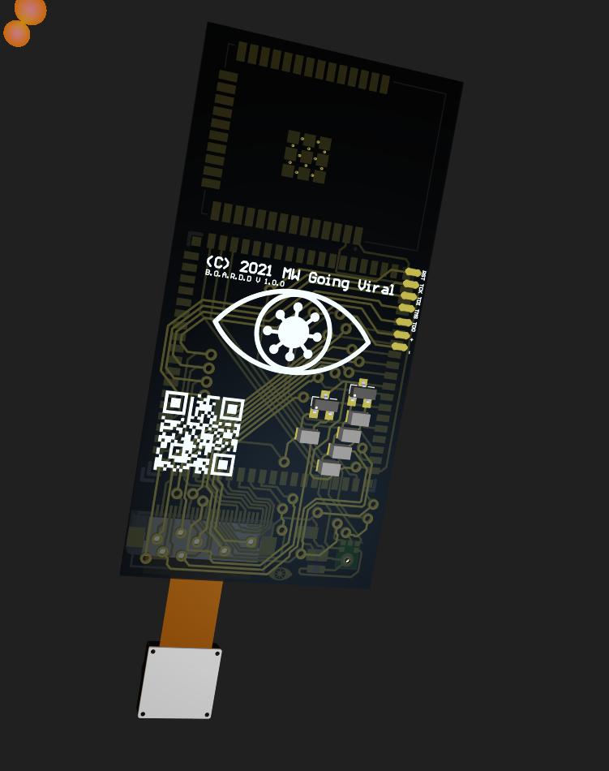

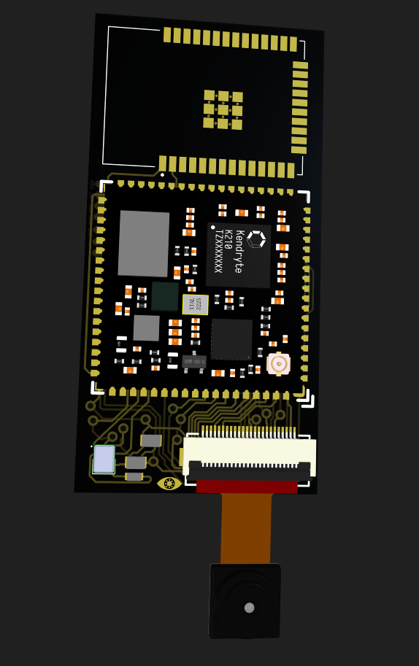

M1 Chip

Camera

ESP32

I2S Microphone

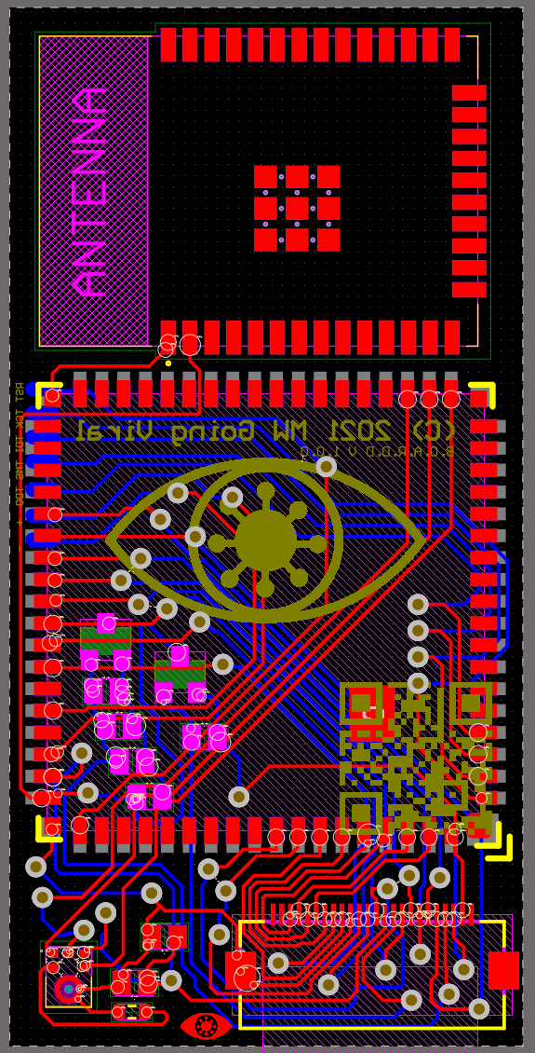

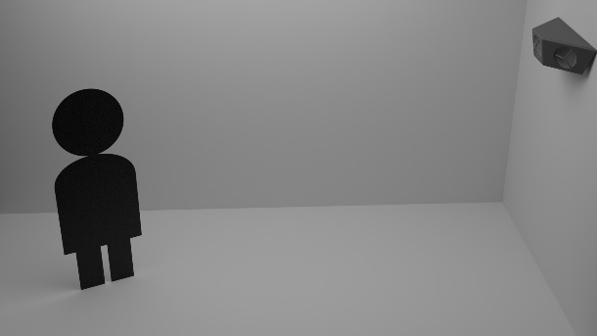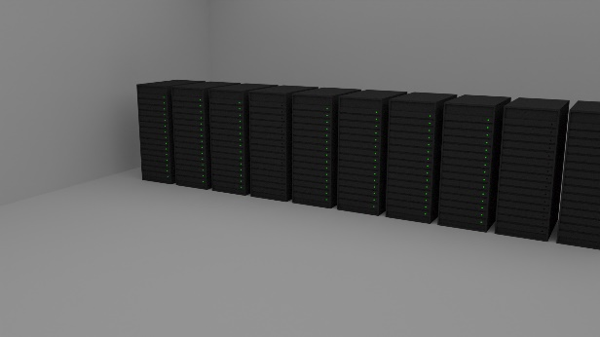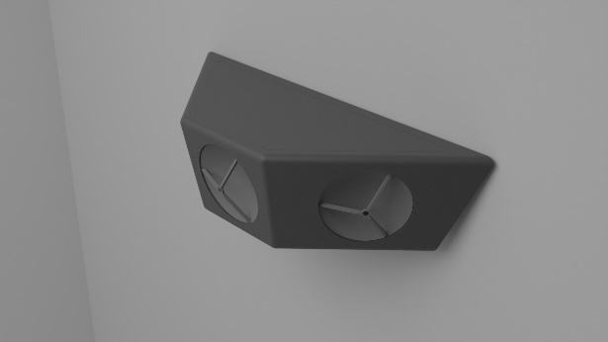

* **User Interface of the Website/Server:** The world map displaying geospatial disease data is the main part of the website. This is where the users can see geospatial datasets of disease case data either one at a time or multiple datasets displayed as an animation over time. Shown below is an early version of the map control UI, where the uninitialized values are displayed to show what information is displayed where, and all the values have IDs so that the JavaScript can control them. The values displayed are dependent on the dataset’s JSON files that contain all of the geospatial data and also other value for the data set, such as the highest number of cases (Which defines what the brightest part of the map means), and the lowest number of cases in an area (Which means 0, which is different from no data).
* Display of User Interface:

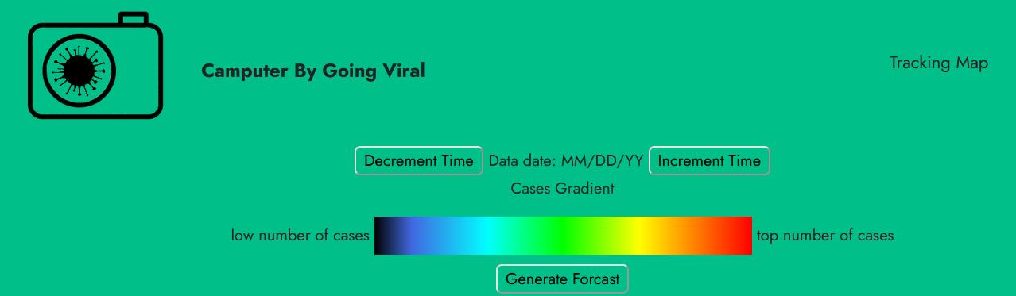

* **What the Data Is & How It Is Used:** Currently, the site only displays one layer of data, the layer showing where the disease being tracked is, and in what intensity. Another layer of data that has been used before on an earlier version of the site is a layer of pins. Where each pin is an individual BOARDD, and when the user puts their mouse cursor over it, it displays the number of cases detected by that device specifically. That feature is currently being added to the current site. The other layers being added (Along with controls to toggle them on/off) are a layer to show the coverage of our computer devices. Showing a map of what areas, we have devices tracking disease cases and what areas we don’t. Along with a map of traffic data (Similar to the one shown in Google Maps or Azure Maps) and a map layer showing population density. Those last two layers are going to be used for the forecast feature, which is currently being made, and will use population density, traffic density, and a disease profile JSON file that will contain any known information about how the disease spreads. Such as how well it spreads in warm temperatures vs cold ones. Does it thrive in more humid environments? and so on. This disease “profile” can be changed when more information is known. The term “traffic data'' includes using Microsoft’s Azure Maps API to see how busy roads are to estimate the chances of a case of the disease spreading to a new area, and airline data, so that if BOARDD(s) is installed on an airliner, then the algorithm knows that there are cases on a flight heading to a city, and can model the spread accordingly. The data from our BOARDDs only store location and number of detected cases, nothing else. There is no personalized data in any part of this website, only the number of cases, where they are, and existing public aggregate data, such as traffic data and population data, to help predict the spread.
* Map Display:

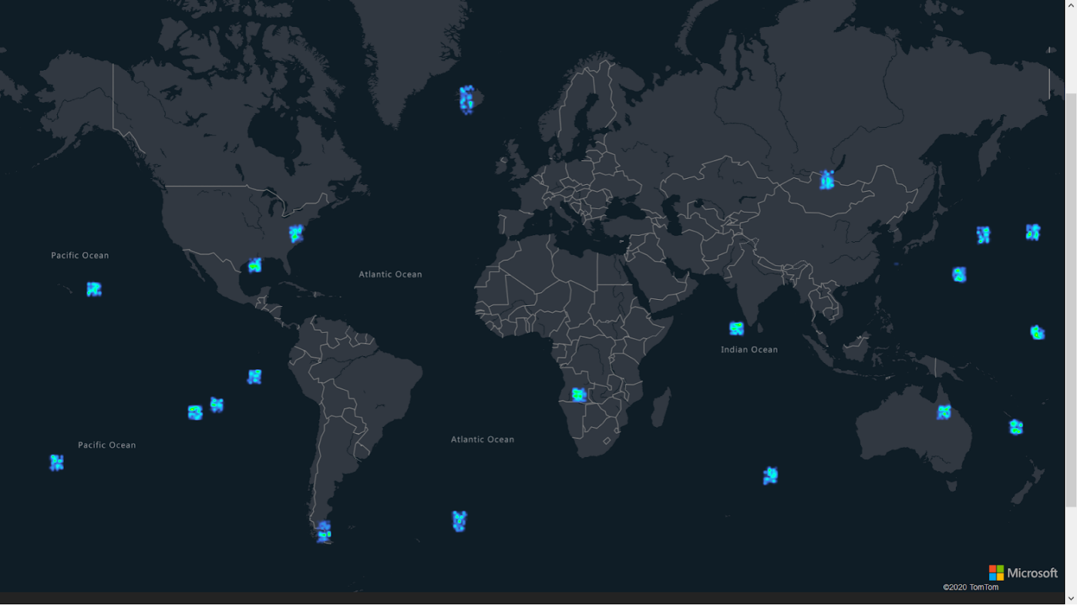

* **Server Design:** The server currently runs on a raspberry pi 4B, the website is hosted on that device for testing purposes and also hosted at [westcs.club/going_viral/](https://westcs.club/going_viral/)(Currently in progress not guaranteed to work). The redundancy was added after a power outage corrupted the drive on the raspberry pi that was running the server and hosting the site. Currently, the server backend consists of a Java program that can read, modify, and generate new geoJSON files, and alter them based on the input from other geoJSON files. The randomly generated test data was made using this program, which randomly made “clusters” of cases at random coordinates, and then made “newer” test data that made a new geoJSON file where the cases, and their magnitude, were shifted and changed. That was for demonstration of the website’s and server’s ability to store, process, and display data to users. Currently in development is adding more code to process additional layers of data, and keep all of the different datasets organized. The datasets are stored as geoJSON files, and CORS is enabled to allow for the client-side to load those files from the server (Only in the website’s directory and subdirectories).
* **Sever:**

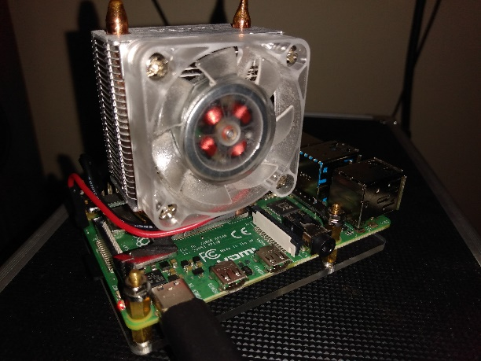

* **How Data Is Stored:** So far, we have made several different approaches to how to best make this website happen. Originally the plan was to use Google Maps and just pins showing the BOARDDs location and case count, which were to be stored in a SQL database on the same server as the website. After doing more research into ways to display geospatial data, we found that the best way to store this data that integrated well into Azure Maps API was to use geoJSON files, where are just JSON files that store points, polygons, and other symbols that are used in displaying maps. We also tried using GPX files, where are XML files that store similar data, but they were not as widely supported by mapping APIs (Specifically Azure Maps, the API the website uses). One of the biggest disadvantages of geoJSON files is that they take up quite a lot of storage space, much of that text in the geoJSON files is redundant, and could be removed. As this BOARDDs scales up, there could be many thousands of BOARDDs, and with multiple geoJSON files for every hour (Raw BOARDD data, process data for the map, map of where there are no BOARDDs), it begins to take up lots of space, just a few hours of data on this scale would already be about a dozen gigabytes based on the size of the randomly generated files shown above. To fix this, the server could either use a very large amount of storage to store months of data, or compression could be used, or accuracy could be lowered. Because the geoJSON files have so much repetitive text, they compress quite well. Hourly records are also not strictly necessary, it could be hourly records for the past week, and only days after that, vastly shrinking the size of the data store for this project. Custom archive files could also be used, which could be made far more efficient than the geoJSON files. Those are some of the solutions we are currently considering or trying to implement to help make the website/server more capable.
* **In Progress Work on Website/Server:**
* More map data layers (BOARDDs coverage, info used in forecasting) and controls to toggle them on and off
* More backend code for making and organizing those data additional data sets
* Forecasting program that can load all of the data used in forecasting and output a geoJSON file that estimates the spread in a reasonably accurate way
* [Home (westcs.club)](https://westcs.club/going_viral/index.html) link: https://westcs.club/going_viral/index.html
* **Dream Website[1]:**
* If we were to have weeks, or even just days of hourly data showing the spread of a disease, in this case, the BOARDDs are designed to track COVID-19, a machine learning algorithm that considers all of the sources discussed above, and automatically weighs them or adjust the profile to better predict the spread of the disease. The final form of the forecast would use machine learning taking the BOARDD data (Including where/how much coverage there is), along with disease profile, weather data, census data/population density, and traffic data of vehicles.
* Dozens of sources of census data and weather data to predict diseases with (Once again all aggregate data, nothing personal)
* Make the world not flat again (Most important 😉)
* **Dream Website View:**

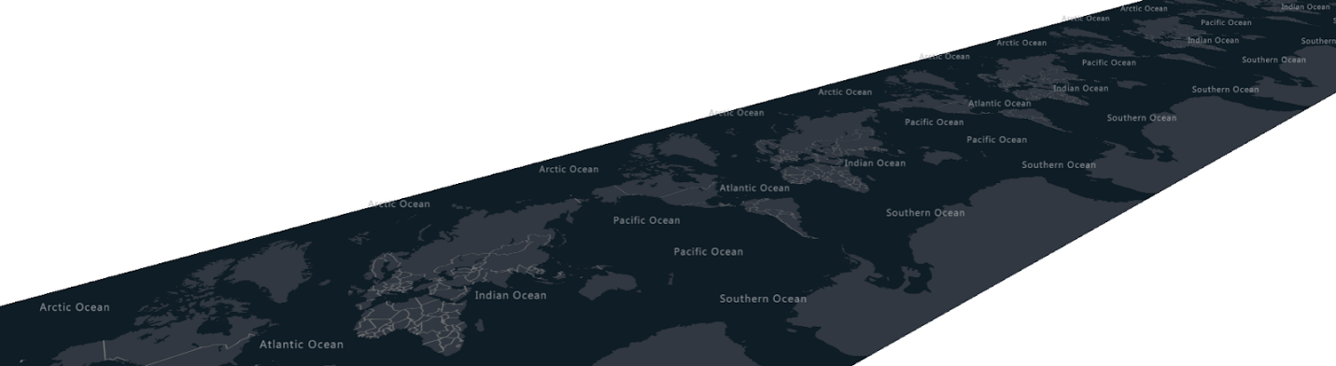

* BOARDDs Operations Flowchart:

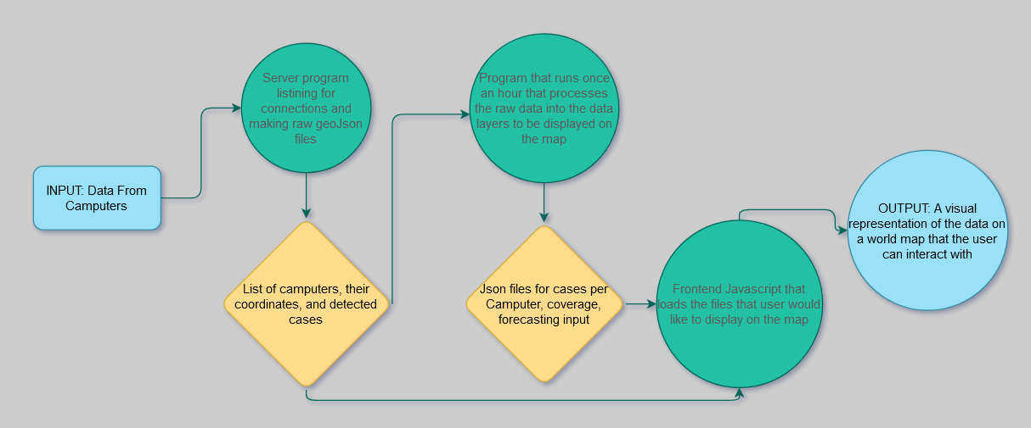

# Market Analysis

The industry that our BOARDD is going to be part of is a new market due to the COVID-19 pandemic. Our main customers are aimed to be airlines, governments, hospitals, businesses, and other public facilities. We would be aiming to help deliver more accurate and reliable data for our customers to eliminate liabilities, make more informed decisions, provide better reports, and so much more. Currently, our competition is imaginary. Since this is a brand-new market, it is untouched. When competition comes we plan on maintaining our accuracy and diversity to set us apart from them. Our accuracy and diversity in infectious respiratory disease diagnoses are our strongest strengths of the BOARDD. We are currently looking into diversifying the diseases that we can diagnose along with bettering our display of the data. Additionally, we understand that there will be threats and weaknesses to our company. However, we plan to address our weaknesses and use our strengths to better ourselves compared to our possible threats.

* **Industry Type:** Thanks to the COVID-19 pandemic, the BOARDDs in question are part of a new untapped market. Due to this, there is no data on the future revenues for the industry. However, because this is an online service, the potential customers are considered to be almost anyone with an internet connection. We are specifically focusing on the people that are interested in avoiding disease (Mainly people living in cities). We are also aiming on targeting hospitals, governments, and other public facilities as possible markets for our product.
* **Market Segmentation:** BOARDD would be marketed towards cities, countries, governments, businesses, hospitals, airlines, and any other public facility. BOARDDs would provide better data for cities and countries to make more educated decisions about their infected peoples and how they should address closures, policies, mandates, and other social and economic decisions. Businesses could use BOARDDs to eliminate liabilities, address policies, and other decisions that could lead to closures and the continuation of their business. Hospitals could use our data collected with the BOARDDs to better report on infectious respiratory diseases. Airlines can also greatly benefit from our BOARDDs. We expect our market to grow over the next few years too as the awareness grows for the spread and reporting of infectious diseases continues and people look into personal protection.
* **Competition:** Currently there is no other service or company that has anywhere near this kind of speed and accuracy. This is a brand-new market that has been opened up by the COVID-19 pandemic. When addressing future competition, we see ourselves as being more direct and accurate than most other solutions. Our BOARDDs can have up to over 90 percent accuracy for diagnosing disease through a cough. Additionally, it tracks this data and displays it along with data published by hospitals, governments, etc. Our BOARDDs are also very user-friendly. We are trying to make it so that our customers can understand where a certain disease is and spread awareness on such a disease. Besides, our BOARDDs can be used not only for the current COVID-19 pandemic diagnoses but also for any other disease that will have a cough as a symptom. With the immense diversity of our product paired with both its impressive accuracy and depiction of the data, we foresee our business as being very successful even with competition if it may come.
* **SWOT Analysis:** Our strengths of our BOARDD include its high accuracy for COVID-19 diagnoses currently. This means that we can easily apply this machine-learning algorithm to other infectious respiratory diseases. With this diversity and accuracy, we can become leaders in our new market. Additionally, our BOARDDs are very necessary for the world that we live in today and thus we made it very user friendly too. We have high accuracy and low latency data which makes our system markedly unique. It also allows for disease tracking on a similar level on how well the weather is tracked and will better our society with such. Our weaknesses include difficulty in gathering large data sets due to lack of their existence. We also currently have a weakness in deciding the final destination of our devices. Also, we have a weakness in deciding a way to render the map with the data collected from multiple rates of infection. Besides, it is not very effective unless used on a large scale. Plus, the accuracy is less than perfect. All of these weaknesses, however, are being addressed currently and we are seeing impressive results and gains in these areas. Our current opportunities include our ability to diagnose new and old infectious respiratory diseases with improving accuracy. Also, we can find and predict new and emerging infectious respiratory diseases. Being able to depict more diversified data. Besides, we are in a brand-new market letting us set the standards for the future too. Plus, applying a machine-learning algorithm to help predict spread based on BOARDD data will benefit the BOARDD greatly. An accurate warning to where the disease is and will be can also be provided. However, we do have some threats. These include both increased research and BOARDDs in the medical field technology and future competition. When addressing these, we just plan on maintaining our quality, accuracy, and diversity to set us apart along with the fact that our BOARDD is so cheap and reliable. While there will always be a problem with server downtime, people believing it is too much surveillance and a violation of privacy, and devices becoming damaged by elements/people/etc., we plan to just address them as they come and to constantly improve the BOARDD.

|  |  |  |
| --- | --- | --- |
| STRENGTHS   * High accuracy * Can be applied to any infectious respiratory disease (not just COVID-19) * Untouched market * Very necessary * Very user friendly * A unique innovation * Allows for disease tracking on a similar level of how well the weather is tracked. |  | WEAKNESSES   * Difficulty gathering large data sets * Difficulty choosing the final destination of BOARDD * Way to render the map with the data collected from multiple rates of infection * Not very effective unless used on a large scale * Accuracy is less than perfect |
| OPPORTUNITIES   * Ability to diagnose with improved accuracy * Able to depict more data * Diversify data from disease diagnoses and spread * Brand new market * To find and predict new and emerging infectious respiratory diseases * Applying a machine-learning algorithm to help predict spread based on BOARDD data * To provide accurate warning to where diseases are and will be | THREATS   * Increase medical field technology * Future competition * Server downtime * People believing it is too much surveillance and a violation of privacy * Devices becoming damaged by elements/people/etc. |

# Operating Plan

Our company plans to operate as in infrastructure. We aim to market to our customers as a data collector and do not collect revenue on the BOARDDs. We want to focus on gathering a net of data rather than a profit. Even though there is every opportunity to gain revenue, it is better that we keep the price low and just use our BOARDDs to collect data. The more BOARDDs that are in the public, the more data that comes in and can be used to forecast and show the spread of infectious respiratory diseases. Our cybersecurity aspects would be focused on not collecting and holding the audio and video feeds that our BOARDDs receive. Rather we would just be using the data that the BOARDDs transmit to our server. Our main customers for BOARDDs include but are not limited to: Hospitals, airlines, governments, cities, businesses, and many other public facilities. Our current team members are keeping our BOARDDs constantly evolving and addressing the problems as they occur. Additionally, thanks to the BOARDDs being wireless devices we can just run the server and other behind the scene actions in our homes.

* **Order Fulfillment:** We plan on just shipping our devices to the customers. There is no need for us to have an elaborate system. The BOARDD would be easy to install and we would be able to just receive the data wirelessly. We would just be keeping track of the number we have sold so that our data displays can be accurate in their rates and forecasting.
* **Payment:** In terms of payment, we plan on selling our BOARDDs at $25 exactly. Our goal for BOARDDs is to be an infrastructure and be easy to start up as it needs to operate on a large scale. We want our BOARDD to act as infrastructure as efficiently as a bridge or traffic light. It would help better society with its data that is provided and would provide the communities it is in with a set of data. We also want to make this BOARDD cheap enough that deployment in large amounts is financially feasible.
* **Cyber Security:** For the cybersecurity part of our BOARDDs we focused on making sure public data is as secure as possible. For that reason, no video footage will be recorded and stored anywhere on the devices nor the servers. The same goes for audio as well. The only way to get access to the server is with RSA keys through ssh, ensuring that the server is secure, but can still be maintained by the server admins. There is no chance for a data breach, as there is no personal information stored, and all of the data on the server is displayed on the website.
* **Key Customers:** Our main customers are aimed to be cities, countries, businesses, governments, hospitals, airlines, and other public facilities. The BOARDD will help businesses when addressing possible closings, policies, the risk to employees, and eliminate possible liabilities. Cities can use our BOARDD to optimize closings and provide a better data set that can help them make more informed decisions about their economy. Countries will be using our BOARDDs to better predict disease spreads and how it truly spreads which can help show all developments and losses in containing it, treating it, etc.
* **Key Employees and Organization:** Currently our team members have many key skills that will greatly benefit our company. Machine learning, cybersecurity, server upkeep, website creation and management, and so many other skills are currently at work and have been keeping our company running. Plus, with these talented team members, we have been able to constantly better our company and address the problems when they occur.

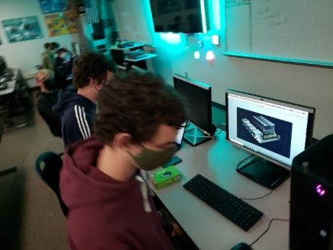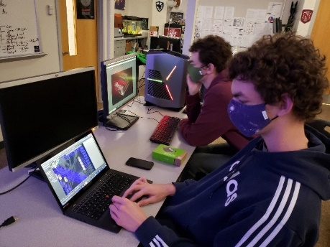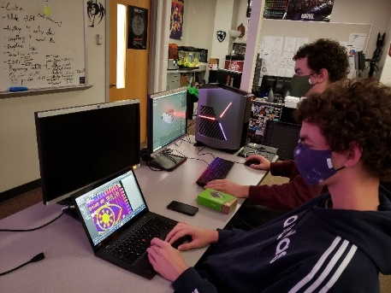

* **Facilities:** Our facilities would be mostly from our homes as our devices would be stationed in public facilities including hospitals, airplanes, government, cities, businesses, etc. We would be running our server from our homes too, and the data would be sent wirelessly.

# Marketing and Sales Plan

Our company is planning on being an infrastructure company. We plan on collecting revenue through having our BOARDDs spread through communities paying for our services in disease tracking and prediction. Our data collected from the BOARDDs is invaluable. It forms a net of data that can be used for many various uses depending on the users of the BOARDDs. Businesses can use it for policies, understand the risks for employees, eliminating liabilities, and so much more. Cities, countries, and governments can use our data for better reports and see how infectious respiratory diseases spread and if a vaccine is truly effective or not. Hospitals can use the data for better reports. Airlines can use the data to evaluate policies, risks, and marketing. Depending on who buys the BOARDDs decides which benefits they reap.

* **Key messages:** Our innovation includes a BOARDD that can diagnose a disease from a cough with over 90 percent accuracy as of with COVID-19 (And or any other infectious respiratory disease), and it will send the data to our server which will forecast and depict the current spread of the disease onto a very user-friendly website.
* Marketing activities:
* Community pitches
* If we get one community using our BOARDDs, we can use them as a testament to all the other future customers
* Word of mouth
* **Sales strategy:** Our main strategy is to pitch our BOARDDs to a community. Once they see how great our BOARDDs are and how they will benefit their economies, they will see our effectiveness. Others will then pick up on this technology and it will spread that way to form a set of data.

# Financial Plan

Our company plans on making revenue from government and community funding. Our product is designed to be an infrastructure in the fashion of roads and bridges. Our product allows for a better economy because better planning and handling of infectious diseases can happen so that we avoid the economic problems that covid-19 caused. Communities/local governments will buy our product as a way to protect their communities and protect their economies from infectious diseases. Our start-up cost will be covered by the first communities that invest/purchase our BOARDD devices and services. To cover the costs of maintaining BOARDDs monthly or yearly maintenance fees can be charged, and prices will come down as production becomes more standardized.

* **Projected start-up costs:** Our startup costs are rather limited since our devices only cost $25. To start with a town of thousands we only need a few hundred devices at most, which means that we are only spending a few thousand on devices (Manufacturing is done by the team at the start). And the server and website are already set up, so the starting cost is only a few thousand dollars (Depending on population and coverage), and monthly costs are only the cost of internet service and power to the devices. Making this service a low-risk investment for any small town or community. With a low start-up cost, this innovation will easily start spreading and expanding coverage and becoming more and more effective

|  |  |  |  |
| --- | --- | --- | --- |
| ITEMS |  | PRICE | AMOUNT |
| PCB |  | $0.80 | 1 |
| Sipeed M1W |  | $8.70 | 1 |
| OV2640 Camera |  | $1.00 | 1 |
| Mems Microphone |  | $1.00 | 1 |
| Miscellaneous SMD |  | $0.50 | 1 |
| Assembly |  | $3.00 |  |
| **TOTAL** |  | **$15.00** |  |

|  |  |  |  |  |  |
| --- | --- | --- | --- | --- | --- |
| PROFT & COSTS | YEAR 1 | YEAR 2 | YEAR 3 | YEAR 4 | YEAR 5 |
| Profits | $25,000 | $175,000 | $1,250,000 | $2,500,000 | $5,000,000 |
| Advertising/Marketing (11.2%) | $2,800 | $19,600 | $20,000 | $20,000 | $20,000 |
| Employee Salaries | $37,536 | $37,536 | $37,536 | $37,536 | $37,536 |
| Employee Payroll Taxes and Benefits | $15,143.78 | $15,143.78 | $15,143.78 | $15,143.78 | $15,143.78 |
| Computer Software | $600 | $600 | $600 | $600 | $600 |
| Insurance | $1,200 | $1,200 | $1,200 | $1,200 | $1,200 |
| Interest Expense (50k Commercial Loan – Pay off in year 3) | $1,368 | $1,368 | $1,368 | $1,368 | $1,368 |
| Supplies | $15,000 | $105,000 | $750,000 | $1,500,000 | $3,000,000 |
| Power Cost | $910 | $6,370 | $45,500 | $91,000 | $182,000 |
| Internet Cost (10mbit/s) | $300 | $300 | $300 | $300 | $300 |
| Travel | $2,400 | $2,400 | $2,400 | $2,400 | $2,400 |
| Professional Services – Legal, Accounting | $1,200 | $1,200 | $1,200 | $1,200 | $1,200 |
| **TOTAL** | **$9,086** | **$28.22** | **$324,752.22** | **$830,620.22** | **$1,738,252.22** |

|  |  |  |  |  |
| --- | --- | --- | --- | --- |
| START-UP COSTS | | | | |
| BOARDD | | April 21, 2021 | | |
| COST ITEMS | MONTHS | COST/ MONTH | ONE-TIME COST | TOTAL COST |
| Advertising/Marketing | 12 | $233.33 |  | $2,800 |
| Employee Salaries | 12 | $3,264 ($34/hour) |  | $37,536 |
| Employee Payroll Taxes and Benefits | 12 | $1,316.85 (5.58% Income Tax, $94.56 Benefits) |  | $15,143.78 |
| Computer Software | 12 | $50 |  | $600 |
| Insurance | 12 | $100 |  | $1,200 |
| Interest Expense for a 50k Commercial Loan | 12 | 3.42% |  | $1,368 |
| Supplies | 12 |  | $15.00/ BOARDD | $15,000 |
| Power Costs |  |  | $0.91/ BOARDD | $910 |
| Internet Costs (10 mbit/s) | 12 | $25 |  | $300 |
| Travel | 12 | $200 |  | $2,400 |
| Business Licenses/Permits/Fees/Patents |  |  | $6,100 | $6,100 |
| Professional Services – Legal, Accounting | 3 | $400 |  | $400 |
| Cash-On-Hand (Working Capital |  |  | $3,500 | $3,500 |
| ESTIMATED START-UP BUDGET WITH LOAN MONEY INCLUDED |  |  |  | $9,086 |

1. Probably not possible with current time/resources, but if we could we would